Database Management System:
DBMS is a software that manages databases and allows users to access data using SQL Commands.

RDBMS – MySQL, PostgreSQL. Data Stored in tables.
DBMS – MongoDB. Data is stored in files.

Database:
A database is an organised collection of data.

SQL:
SQL – Structured Query Language
SQL is a language used to communicate with a database through a DBMS.

By using SQL commands, we can create databases and tables, insert, update, and delete data. We can also extract data from databases.

When we write SQL commands in MySQL (DBMS software) mysql server will read it, understand it and validate it and then finally execute the SQL commands we wrote.

User --> SQL --> DBMS --> Database

User uses SQL commands in MySQL to access the database.
Access in terms of creating, manipulate the data.

A schema is a logical container that groups related tables inside a database to keep data organized.
Database
├── sales (schema)
│ ├── customers (table)
│ └── orders (table)
└── hr (schema)
├── employees (table)
└── payroll (table)

Database objects are structures used to store data, improve performance, and organize a database.
Table
View
Schema
Constraint

---------------------------------------------------------------------------------------------------------------------------------------------------------

SQL DDL and DML Commands:

Command: create database <database_name>
Will create a new database

Command: Show Databases;
Used to show databases in the DBMS.

Command: Use Database_Name;
By using that command, we can perform operations on a particular database.

Command: show tables;
Show all the tables we created in that database.

Command: desc tablename;
Used to show the structure of the table (columns) details.

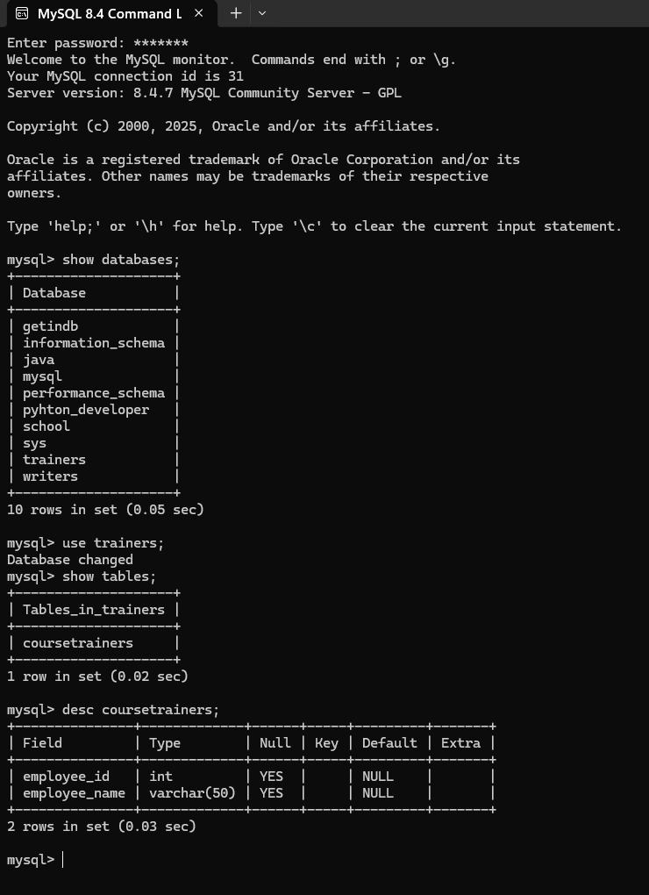

Command: desc tablename;
Shows the structure of the table. Column name, and it’s datatype, and other details.

Command: alter table coursetrainers add joindate date;
Here, By using alter here we add the column name as join date and we declare it’s datatype is date.
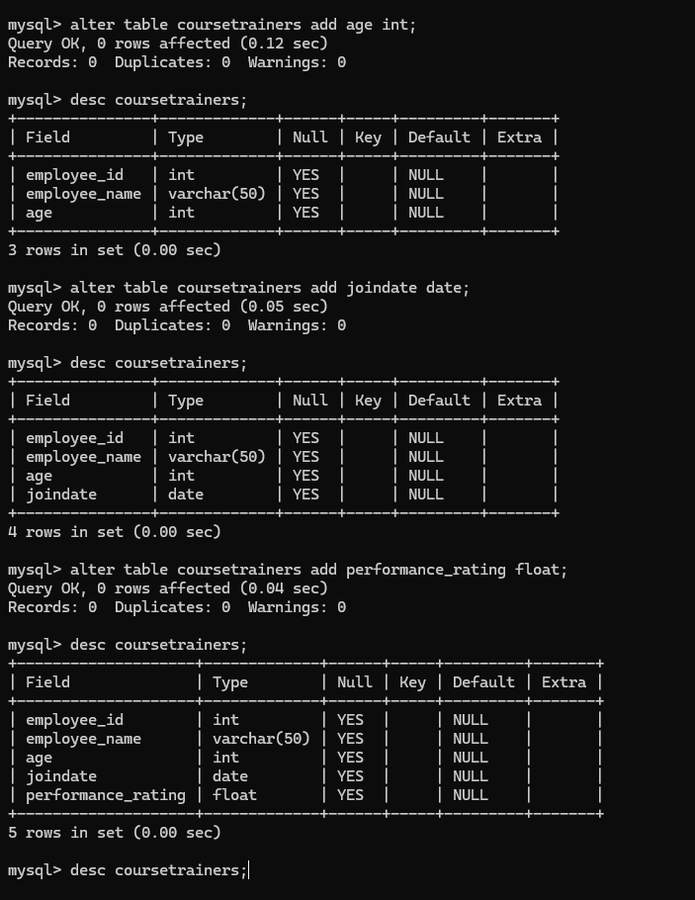

Command: create table coursetrainers_7(id int primary key auto_increment, name varchar(50));
By using this command we created the table and the table contained the columns details like primary key, which datatype and so on.

Command:
we can insert data inside the table by using few methods like once we create a table we can add the multiple records or single record, and we can add particular data by mention the column name and add the values into that cell.
Command: Insert into coursetrainers_7 values(101, “ramu”);
Here, the command is used to insert the record in the table. The table(coursetrainers_7) is already created.

Command: insert into coursetrainers_7(name) value(“raja”);
Here if you can see that in that table coursetrainers_7 we only insert the single cell value(raja) in the column (name).
Command: insert into coursetrainers (employee_id, employee_name, age, joindate, performance rating)
Values(2,’kumar’,32,’2022-01-01',9.2),(3,’akash’,33,’2020-01-02'’,9.3);
Here if you can see that two records are inserted.
Here another two records are inserted.
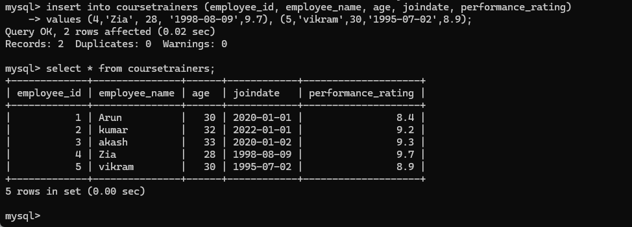
Command: select employee_id, employee_name from coursetrainers;
Here we only extract the two column details from the table.

Command: update coursetrainers set age = 18 where employee_id = 4;
Here we update the age based on employee id equal to 4;

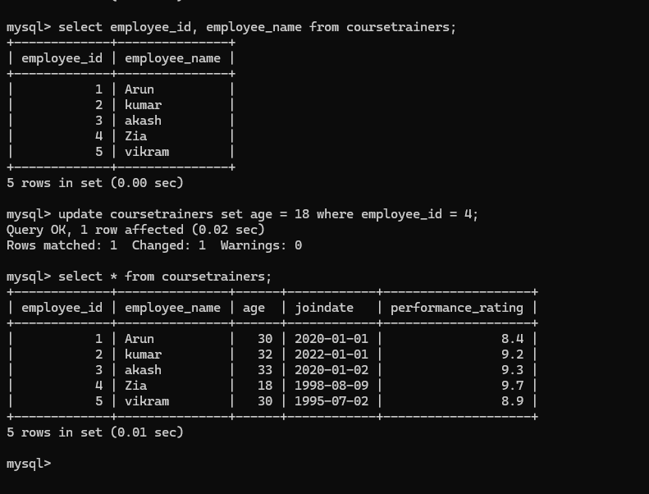

Qurey: create table coursetrainers_1(id int, name varchar(20) not null);
Here we can create the table along with not null constraint is added.
So if we insert data without name then it will throw the error;

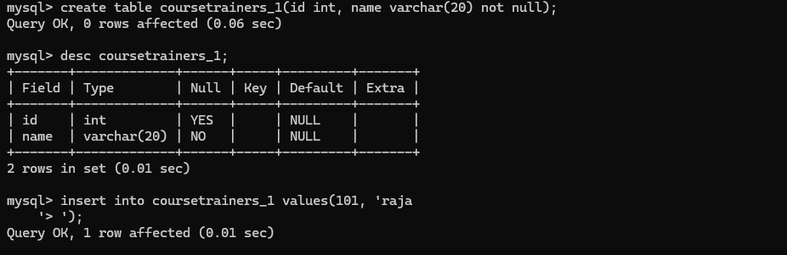



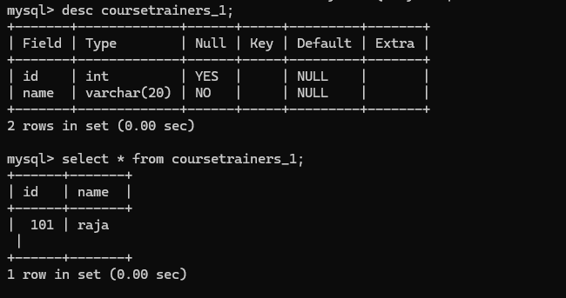

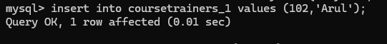

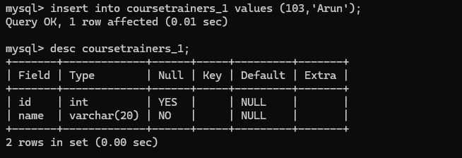

Query: select * from coursetrainers_1;
By using this command we can retrieve the information from the table.

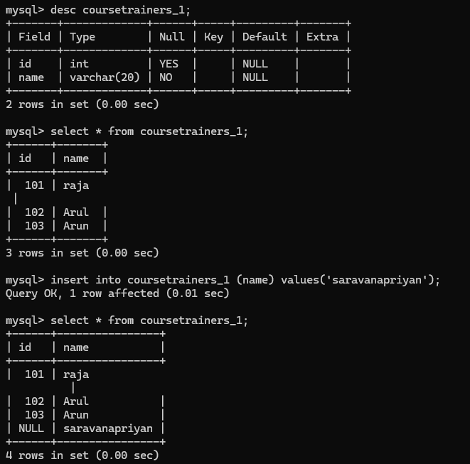

Alter table:

Delete the table:

Drop Table:

---------------------------------------------------------------------------------------------------------------------------------------------------------

Data Types:

----------------------------------------------------------------------------------------------------------------------------------------------------------
Constraints:

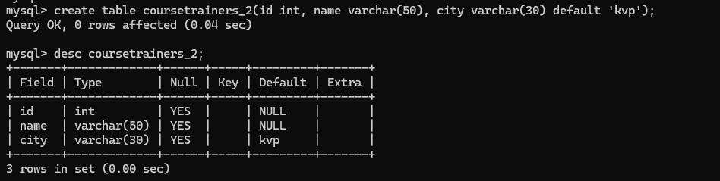

Default constraint:
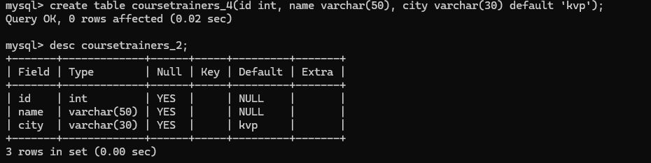

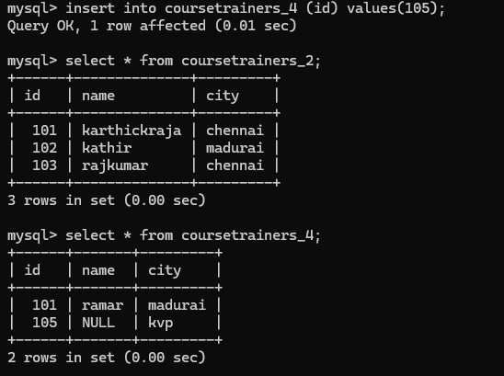

Check Constraint:

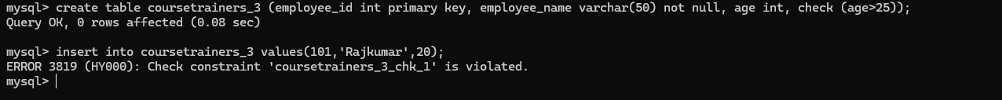

This command throws an error when the input age value is under 25.

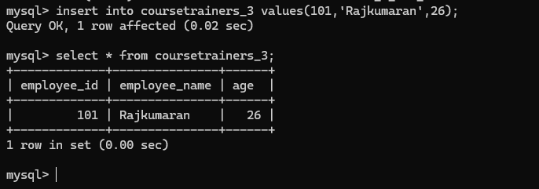

Primary key Constraint:

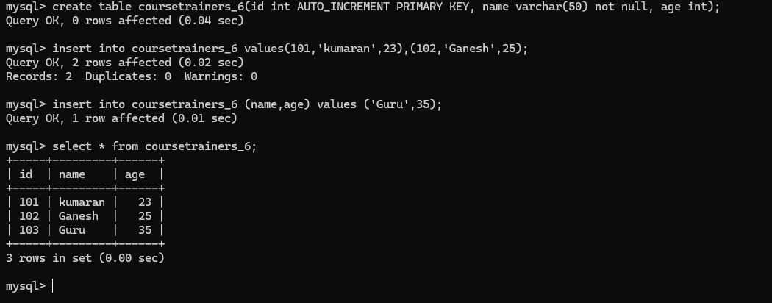
Constraints added primary key, not null, uniuqe, foreign key,check, default,auto_increment.

Auto_increment is a is a column attribute (property) that automatically generates a new numeric value for each inserted row that will controls how values are generated in a table.
----------------------------------------------------------------------------------------------------------------------------------------------------------
Operators:

Arithmatic:
+, -, *, /, %
Relational:
>, <, >=, <=, !=, =, <>
Logical:
AND, OR, NOT
Between:
To find records within range
In:
To find multiple records from same column
Is null:
To find null records
Like:
To apply the regular expression

Arithmetic Operators:
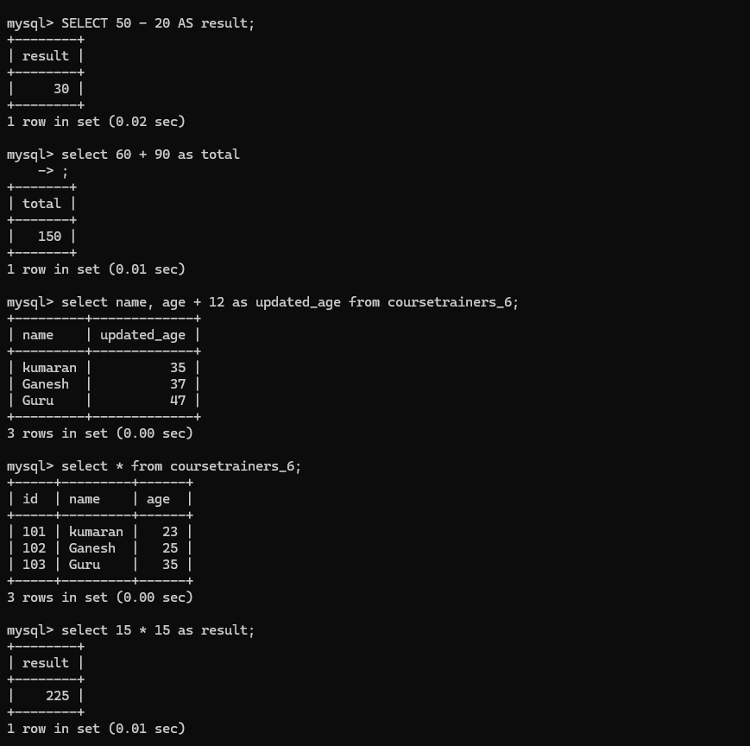

Relational Operators:
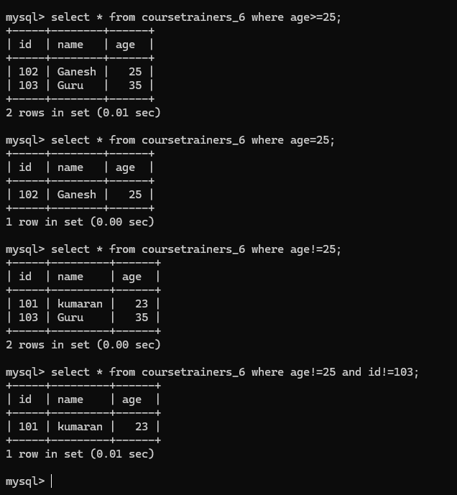

Logical Operator:

In, Between,Iike:

----------------------------------------------------------------------------------------------------------------------------------------------------------MySQL Joins:

Inner Join:

Left Join:

Right Join:

Right join with order and limit.

Full Join using UNION:

select c.cust_id,o.order_id from customers c left join orders o on c.cust_id = o.cust_id union select c.cust_id,o.order_id from customers c right join orders o
on c.cust_id = o.cust_id;

Cross Join:

Cross Join:

How to save joins output:

Left anti join:
Right anti join:

Full anti join using union:

----------------------------------------------------------------------------------------------------------------------------------------------------------

----------------------------------------------------------------------------------------------------------------------------------------------------------
Set Functions:
For set function if the tables we select we must have the same data type for the columns. Number of column and order of column should be same.
Union:

Union: --> ignore duplicate vaues from the table and give result.
Union All --> keep the duplicate values and give result.

----------------------------------------------------------------------------------------------------------------------------------------------------------
Aggregate functions:
Work with rows and provide answer in a single row.

Two table aggregate functions

